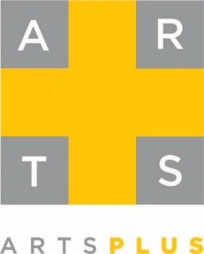
2022 Camp Scholarships and Awards

Bill Williams Band Scholarship: Solo Competition Winner
Bill Williams served on the Arts+ Board of Directors from FY08 to FY14 and was instrumental in securing Piedmont Natural Gas’ support of Jazz Camp since 2009. Jazz Camp was very special to him. Bill was a devoted board member—respected by all. Bill passed away August 1, 2016 from cancer. The scholarship is awarded in Bill’s memory and was first awarded in summer 2017.
Talented students who have registered audition in early June for a full tuition scholarship to camp. The solo competition scholarship winner will perform his/her solo, with accompaniment, at the final camp concert.
Debbie Abels String Scholarship: Solo Competition Winner
Debbie Abels served on the Arts+ Board of Directors from FY03 to FY08 and was chair from FY05 to FY06. The scholarship was named in honor of her service to Arts+ and has been awarded since 2010.
Talented students who have registered for String Orchestra Camp audition in early June for a full tuition scholarship to camp. The solo competition scholarship winner will perform his/her solo, with accompaniment, at the final camp concert.
Tosco Music Scholarships
Established in 2016, Tosco Music funds one full scholarship to music camp. The scholarships are awarded to Band Camps: Concert and Jazz and String Orchestra Camp to outstanding students based on the auditions held in early June.
Tosco Music presents a wide variety of music through performances and outreach programs; fosters a sense of community among listeners and performers; connects professional and amateur musicians to share and inspire one another.
Stan Michalski Scholarship
Established in 2019, the Stan Michalski Scholarship is a full tuition scholarship for Band Camp. The scholarship honors Stan Michalski who was the camp’s conductor for many years.

