 **Charlotte Children’s Choir of Community School of the Arts**

**Girls’ Uniform Ordering Information**

The girl’s formal concert uniform is available from:

**Formal Fashions, Inc.** [www.formalfashionsinc.com](http://www.formalfashionsinc.com)

P.O. Box 11688

Tempe, AZ 85284

(800) 528-7909

**Hours:** Monday – Thursday: 9:00 - 3:00 PST (12:00 - 6:00 EST)

Fridays: 9:00 – 1:00 PST (12:00 – 4:00 EST)

We recommend that you call to place your order to ensure you get the correct item and size. The choices available online can be confusing.

**Steps to Take:**

* Take your child's waist, bust, and hip measurements. Please watch the "how to measure" video on the Formal Fashions, Inc. website: www.formalfashionsinc.com.
* Place your dress order over the phone: 1-800-528-7909. Let them know you are a member of the Charlotte Children's Choir, Customer No.122810. They will create an account for you.
* Order your child's uniform as soon as possible. All items should be ordered by **August 31** to ensure delivery—with time to hem—by the Fall Concert.

|  |  |  |  |  |
| --- | --- | --- | --- | --- |
| **Description** | **Style No.** | **Fabric |** | **Color** | **Price** |
| Crepe Back Satin (Matte Finish) **w/Satin waist design\*** | 4872AA | Crepe-back  Satin | | Navy | $64.00 |
| *please note the waist design is “Satin” (not “satin sash”) |  |  | Shipping: | $15.00 |
|  |  |  | **Total:** | **$79.00** |

**Your dress should be hemmed according to the chart below:**

|  |  |
| --- | --- |
| **Choir** | **Hem Length** |
| Harmony  ___________________________________________________ | 10" from the floor (with shoes on) |
| Lyric, Concert | Floor-length  (If your current dress fits, you are not required to buy a new dress, but If you do buy a new dress, hem it to floor-length.) |

**Shoes:** Black, close-toed, closed-back flats with no added height. (See example below.)

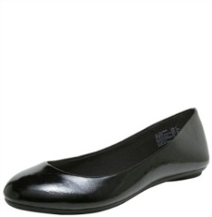

**Accessories:** Hosiery is not required; however, you may select skin-colored hose or footies for comfort at your discretion. Please do not wear tights of any color or dark-toned hose.

Remove necklaces, bracelets, watches, and anklets. One pair of small earrings only.

Please remove colored nail polish.

**Hair:** Using hair-colored elastics, please secure away from the face hair that is shoulder-length or longer in a manner that will stay behind the shoulders. Do not add hair bows, flowers, or other accessories.

 **Charlotte Children’s Choir of Community School of the Arts**

**Boys’ Uniform Ordering Information**

The boy’s formal concert uniform is available from:

**Formal Fashions, Inc.** [www.formalfashionsinc.com](http://www.formalfashionsinc.com)

P.O. Box 11688

Tempe, AZ 85284

(800) 528-7909

**Hours:** Monday–Thursday: 9:00-3:00 PST (12:00-6:00 EST); Fridays: 9:00 – 1:00 PST (12:00 – 4:00 EST)

We recommend that you call to place your order to ensure you get the correct item and size. The choices available online can be confusing.

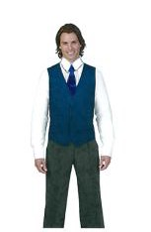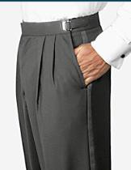

**Steps to Take:**

* Take your child's waist, chest, and hip measurements. Please watch the "how to measure" video on the Formal Fashions, Inc. website: www.formalfashionsinc.com. Specify the age of the child to ensure child-sizes where needed.
* Place your order over the phone: 1-800-528-7909. Let them know you are a member of the Charlotte Children's Choir, Customer No.122810. They will create an account for you.
* Order your child's uniform as soon as possible. All items should be ordered by **August 31** to ensure delivery by the Fall Concert.

Harmony Choir

Lyric Choir and Concert Choir

|  |  |  |  |
| --- | --- | --- | --- |
| **Description** | **Style No.** | **Color** | **Price** |
| Adjustable Tuxedo Trousers | 6502 | Black | $24.00 |
| White Lay Down Collar Tuxedo Shirt | 2121 | White | $15.00 |
| Satin Windsor Tie (Royal Satin [Shiny Finish]) | 8261 RA | Navy (NV) | $15.00 |
| You |  | Shipping: | $15.00 |
|  |  | **Total:** | **$69.00** |

|  |  |  |  |
| --- | --- | --- | --- |
| **Description** | **Style No.** | **Color** | **Price** |
| Adjustable Tuxedo Trousers | 6502 | Black | $24.00 |
| White Lay Down Collar Tuxedo Shirt | 2121 | White | $15.00 |
| Satin Windsor Tie (Royal Satin [Shiny Finish]) | 8261 RA | Navy (NV) | $10.00 - $15.00 |
| Vest: Men’s SAV Crepe Back Satin (Matte Finish) | 6289 CS | Navy (NV) | $42.00 |
|  |  | Shipping: | $15.00 |
|  |  | **Total:** | **$106.00 - $111.00** |

**Shoes**: Boys in all ensembles wear black dress shoes with black socks.

**Accessories:** Remove jewelry and watches.

**Hair:** Using hair-colored elastics, please secure away from the face hair that is shoulder-length or longer in a manner that will stay behind the shoulders.